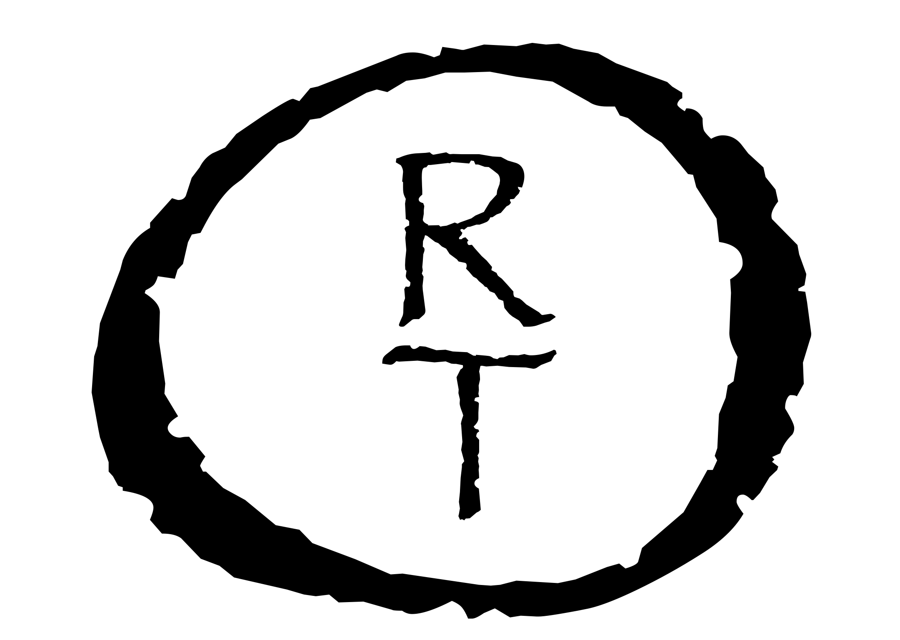
Ryan Thomas Osborne

Education
2014, Master of Fine Arts, Ceramics, Kent State University, Kent, OH
2011, Bachelor of Arts, Studio Art, Concentration in Ceramics, Ferrum College, Ferrum, VA

Employment
2021 - Present: Starworks, Star, NC
Title: Ceramic Supply Shop Manager, Instructor
2021 - 2021: Buckeye Ceramic Supply, Hilliard, OH
Title: Customer Service Representative
2017 - 2020: Ohio Ceramic Supply, Ravenna, OH
Title: Customer Service Representative, Studio Manager, Instructor
2016 - 2018: City of Cuyahoga Falls Parks & Recreation, Cuyahoga Falls, OH
Title: Pottery Instructor
2016 - 2017: Michael’s, North Canton, OH
Title: Sales and Replenishment Associate
2015 - 2016: Michael’s, Roanoke, VA
Title: Framing Associate and Cashier
2014 - 2016: The Rocky Mount Center for the Arts, Rocky Mount, VA
Title: Ceramics Instructor
2013 - 2014: School of Art, Kent State University, Kent, OH
Title: Gallery Assistant
2013 - 2014: School of Art, Kent State University, Kent, OH
Title: Ceramics Laboratory Custodial Technician
2012 - 2013: School of Art, Kent State University, Kent, OH
Title: Teaching Assistant
2009 - 2011: The Little Gallery at Smith Mountain Lake, Moneta, VA
Title: Sales Representative

2005 - 2005: Buffalo Mountain Camp, Johnson City, TN
Title: Camp Counselor

Solo & Two-Person Exhibitions
2023: Starworks @ Sandhills, Two-Person Exhibition with Tara Thacker, Hastings Art Gallery,
Sandhills Community College, Pinehurst, NC
2016: Biomorphic Forms & Drawings, Solo Exhibition, Trumbull Art Gallery: TAG Underground,
Warren, OH
2015: Ebb & Flow, Solo Exhibition, The Rocky Mount Center for the Arts at the Grainery,
Rocky Mount, VA
2014: Biomorphia, Master of Fine Arts Thesis Group Show, Kent State University School of Art Gallery, Kent, OH
2013: Master of Fine Arts Candidacy Exhibition, Solo Exhibition, Kent State University School of
Art Sculpture Gallery, Kent, OH

Group Exhibitions
2024: FireFest 2024 Exhibition, Starworks, Star, NC
2024: Nature & Coalescence, Crossroads Art Center, Richmond, VA
2023: FireFest 2023 Exhibition, Starworks, Star, NC
2022: Fire and Smoke…Wood, Raku, Saggar, Pit Fired and Alternative Fired Clay, Lakeland
Community College, Kirtland OH
Curator: Mary Urbas
2022: EnVision: a Woodfire Invitational, Starworks, Star, NC
Curator: David Stuempfle
2022: FireFest 2022 Exhibition, Starworks, Star, NC
2020: 44th Annual Juried Art Exhibition, Fairmount Center for the Arts, Novelty, OH
2020: Third Ceramics Annual, RampArts Gallery, Cleveland, OH
2020: Kindled Spirits, Good Earth Pottery, Bellingham, WA
Juror: Simon Levin
2018: Alumni Exhibition, Kent State University Downtown Gallery, Kent, OH
2018: Wood-Fired Ceramics of Northeast Ohio, Valley Art Center, Chagrin Falls, OH
Curator: Judith Salomon
2017: Fired in Freedom, Wayne Center for the Arts, Wooster, OH
2017: Fired in Freedom, Trumbull Art Gallery: TAG Undergound, Warren, OH
2017: Earth and Ash, River Gallery, Rocky River, OH
2017: Recent Alumni Show, Center for Visual Arts Gallery, Kent State University, Kent, OH
2017: Fired in Freedom, Gelbke Fine Arts Center Gallery, Hiram College, Hiram, OH
2016: All Ohio Contemporary Ceramics Competition and Show, Yan Sun Art Museum,
Zanesville, OH
2016: Akron Art Prize, Summit Art Space, Akron, OH
2016: PRECIOUS: The Fine Art of Fine Craft, Summit Art Space, Akron, OH
2015: Fired in Freedom, Revision Space, Pittsburgh, PA
2014: Fired in Freedom, Kent State University School of Art Downtown Gallery, Kent, OH
2014: ASM Art Show, ASM International, Materials Park, OH
2014: National Juried Cup Show, Kent State University School of Art Downtown Gallery,
Kent, OH
2014: A Home for Joe, Baldwin Wallace University, Berea, OH
2013: National Juried Cup Show, Kent State University School of Art Downtown Gallery,
Kent, OH
2013: MFA Show, Kent State University School of Art Gallery, Kent, OH
2012: Small Works Competition, Kent State University School of Art Downtown Gallery,
Kent, OH
2011: Senior Thesis Exhibit, Ceramic Sculpture: Biomorphic Forms in Clay, Ferrum College, Ferrum, VA
2011: Annual Student Awards Exhibition, Ferrum College, Ferrum, VA
2010: Annual Student Awards Exhibition, Ferrum College, Ferrum, VA
2009: Annual Student Awards Exhibition, Ferrum College, Ferrum, VA

Professional Activities
2024: Instructor, Raku Workshop, Starworks, Star, NC
2023: Instructor, Raku Workshop, Starworks, Star, NC
2022: Instructor, Raku Workshop, Starworks, Star, NC
2022: Presenter, Sculpture Plenary Panel, Woodfire: NC 2022, Starworks, Star, NC
Interviewer: Garth Johnson
2019: Committee Member, Ravenna Creates! Art on Main, Ravenna, OH
2018: Committee Member, Ravenna Creates! Art on Main, Ravenna, OH
2017: Committee Member, Ravenna Creates! Art on Main, Ravenna, OH
2016: Member of the Canton Museum of Art Ceramics Guild, Canton, OH
2015: Member of the Blue Ridge Potter’s Guild, Roanoke, VA
2014: Juried member of ‘Round the Mountain: Southwest VA’s Artisan Network, Abingdon, VA
2014: National Council on Education for the Ceramic Arts, Milwaukee, WI
2014: Member of the National Council on Education for the Ceramic Arts
2011-2013: “Empty Bowls” Fundraiser, Ferrum, VA and Brecksville, OH
2011: Member of Kappa Pi, International Honor Arts Fraternity, Ferrum College, Ferrum, VA
2010-2011: Member of the National Council on Education for the Ceramic Arts
2010-2011: President of the Art Club at Ferrum College, Ferrum, VA

Skills
Kiln building, hand built and wheel thrown ceramics, electric kiln firings, gas/wood/salt/soda/raku kiln firings, glaze mixing and glaze calculations, experience with a wide range of tools, welding, stone-carving, woodworking, drawing, painting, photography, MS Office, Adobe Creative Suite, curating exhibitions, archiving artwork, installing and deinstalling exhibitions.

